Material 1 zu S16GW5A01

M1 – Karte zur Armut (thematische Karte [Welt])
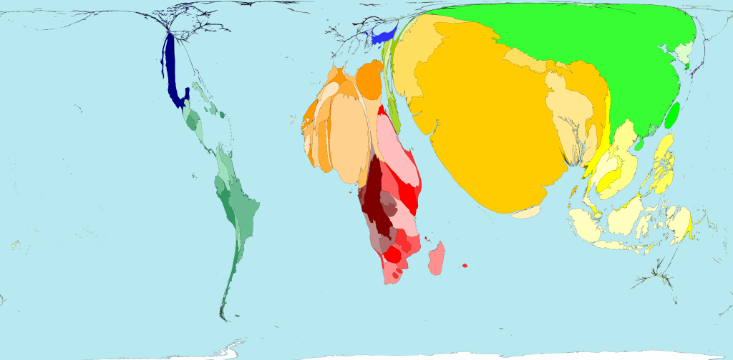
Karte 1: Absolute Armut (WorldMapper o.J.: o.S.)

WorldMapper (o.J.): Absolute Poverty (up to $2 a day. <http://www.worldmapper.org/display.php?selected=180> (Zugriff: 2014-12-01).

