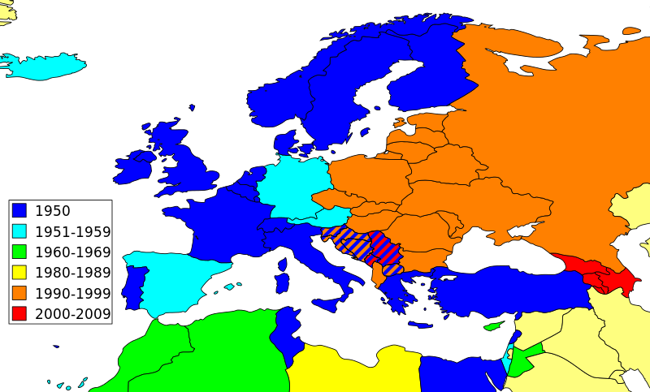
M5 European Broadcasting Union

Dateiname | M5 European Broadcasting Union
Kurzbeleg | Wikipedia 2011: o.S.
Langbeleg | Wikipedia (2011): European Broadcasting Union. <http://commons.wikimedia.org/wiki/File:European_Broadcasting_Union_members.svg> (Zugriff: 2015-03-23).
Lizenz
Materialtyp | Karte – Thematische Karte (Kontinent)

