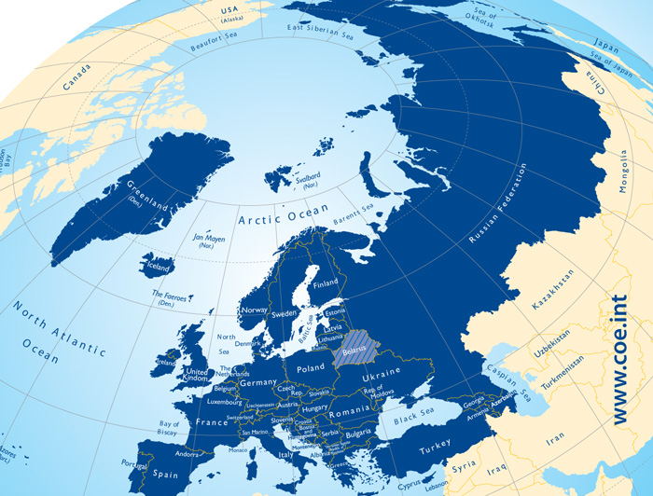
M2 Europa des Europarates

Dateiname | M2 Europa des Europarates
Kurzbeleg | COE 2014: o.S.
Langbeleg | COE (2014): Our member states. <http://www.coe.int/en/web/about-us/our-member-states> (Zugriff: 2015-03-23).
Lizenz | © Council of Europe
Materialtyp | Karte – Thematische Karte (Kontinent)

